FROM: Charity Nduhura (APM) | TO: Dorothy M. Tuma (Director), Board Members
 | DATE: 28th February 2017
SUBJECT: February 2017, Report
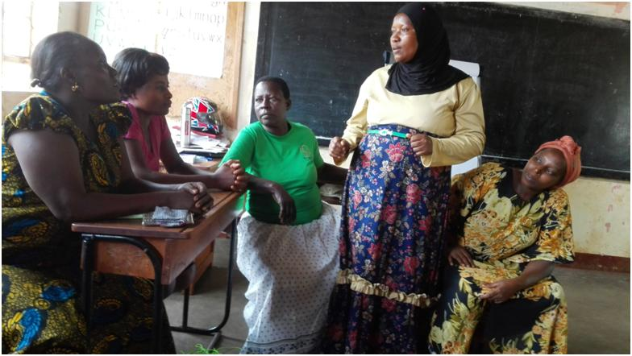Leadership role play

Achievements
1.1 Women in Business (WiB) Quarterly Workshop
The WCFJC WiB Quarterly workshop was held on Wednesday 15th February 2017 at St. Nicholas Primary School, Jinja. The main objective of the workshop was to train and equip WiB participants with basic knowledge and skills in group dynamics and leadership. The workshop was attended by 27 WiB participants.

To kick start the training, four of the participants shared their achievements, progress and challenges in their businesses. Thereafter, the WCFJC Officer oriented the new participants and took them through WCFJC expectations and the loan policy.

The trainer (Mrs. Harriet Nsubuga) covered the following topics:
1. Group formation
a) What is a group?
b) Importance of a group
c) Advantages of a group
d) Disadvantages of a group (always be consistent Charity. If it is a group, it doesn’t have to change to groups in part (d). Choose a format and stick to it.

2. Understanding group dynamics and cohesion
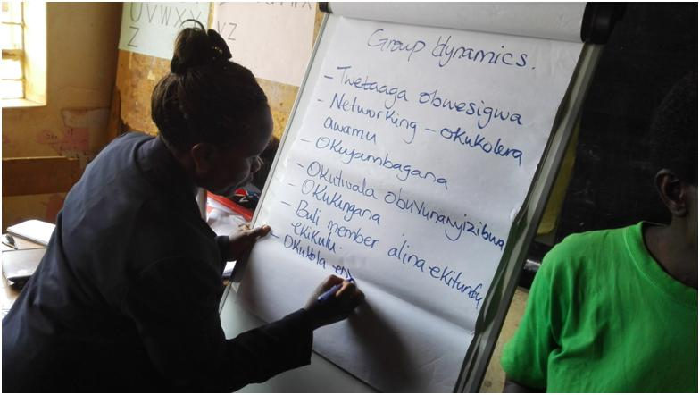Harriet training participants on group dynamics
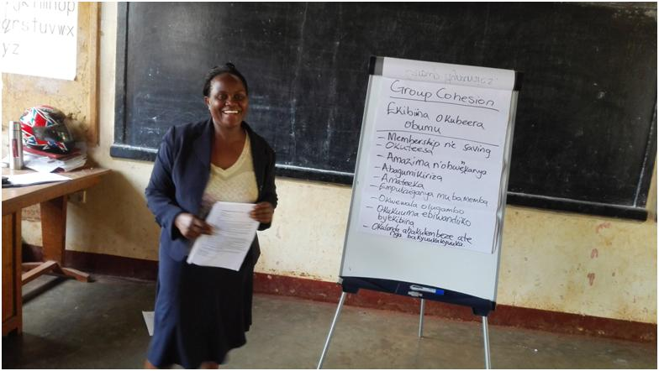Harriet explaining group cohesion to participants

Methodology used to train Group Dynamics
- Demonstration of the human web
- Individual participant observation of the activity

The demonstration was followed with a discussion o on conditions for healthy group cohesion and success.
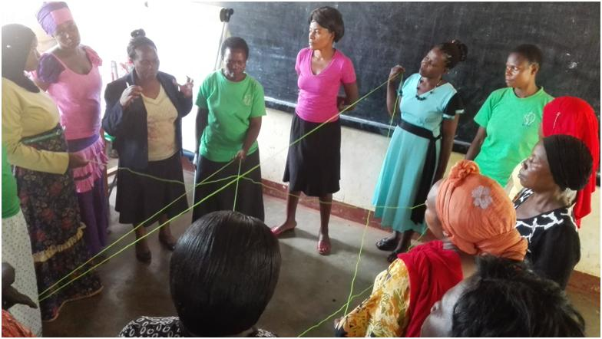

3. Group leadership and membership
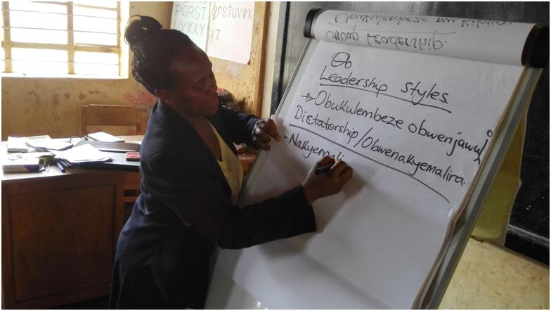Harriet taking participants through leadership styles
The Trainer explained to participants what a group leader is, the roles of the group leader and members.

Role plays were used to bring out different leadership styles. The leadership styles included: dictatorial, democratic and laissez-faire leadership styles.
General discussion to identify the skills employed by each leader and gaps was also held.
The training was educative, interactive and enjoyable. Participants were grateful for the trainer who fluently trained in the local language. It was interesting to the participants for the trainer to write in the local language. They were able to take notes in the language they understand best.
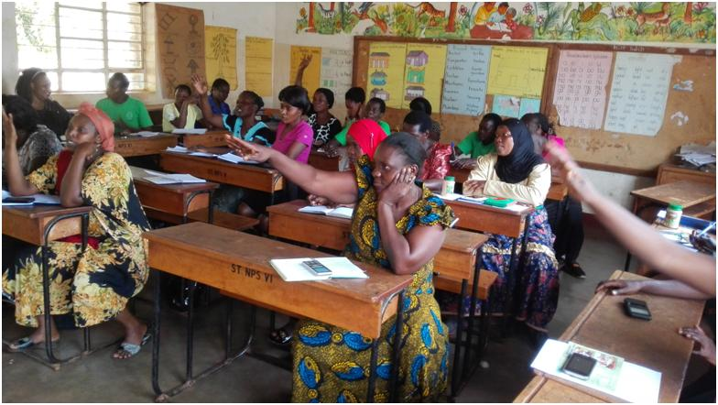Participants raising their views about qualities of a good Leader

Lastly the workshop was concluded with an address by the Bugembe Community Development Officer Representative (Mr. Bukaya Steven). He talked of the importance of groups and encouraged women to work in groups. He requested the facilitators to continue the good work of training women for sustainability of the groups even in facilitators’ absence.

Steven informed participants about government programmes and urged them to participate. He encouraged the participants to apply for loans at the sub-county (Women Fund) to support their income generating projects. He shared the details of the loan programme and procedures for loan acquisition. Participants had an opportunity to inquire about the same programme which Steven answered promptly.
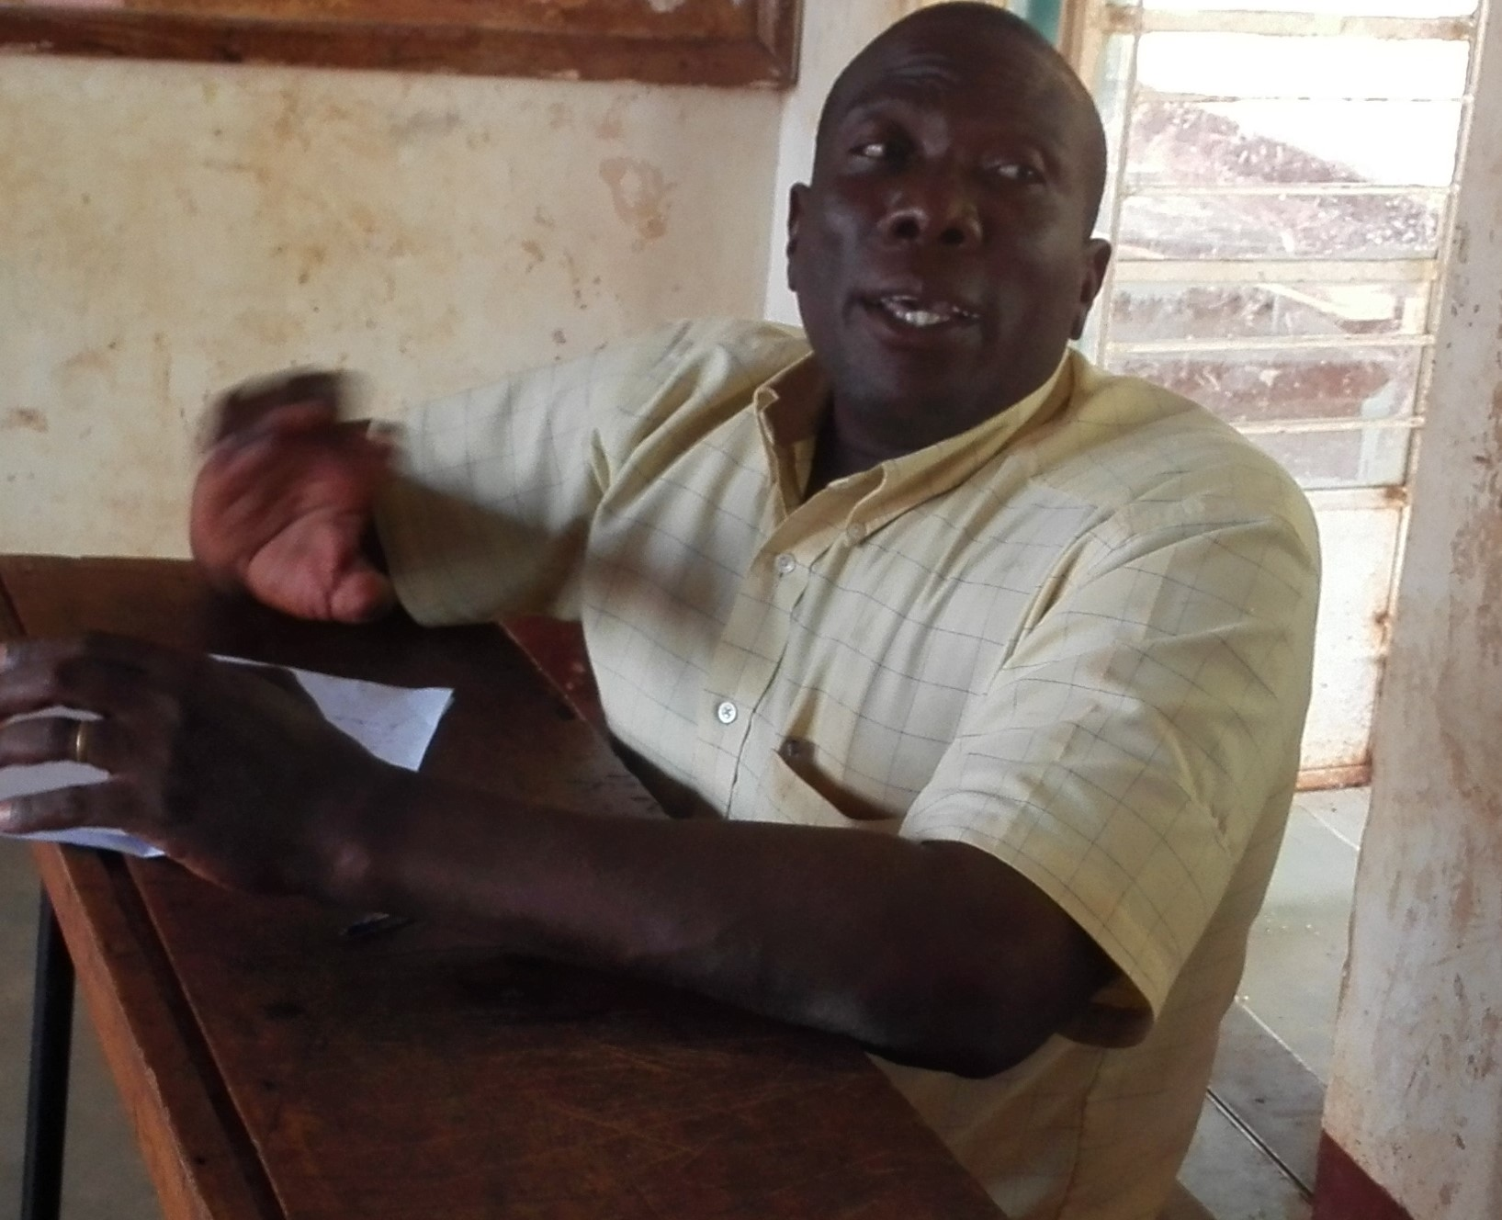Steven addressing the participants

1.2 Women in Business (WiB) phase VII Budgeting
Following the WiB Workshop that took place on 15th February 2017, WCFJC finalized the budgeting process for WiB phase VII. The budget covers both new and continuing participants, who are ready for in-kind loans. A total of 20 participants met the criteria and are ready to receive the in kind loans in the month of March 2017. A summary of the approved loan portfolio is provided in Annex II. Details are available on request.

In addition to WCFJC WiB loan policy, WCFJC considers a number of factors before participants can be recruited for a loan. Among the factors considered include:
- Participants should not be servicing other bank loans. This is mainly aimed at avoiding over burdening participants by paying back more than one loan.

- The continuing participants should have completed paying back their previous WCFJC loan and have obtained approval from the WCFJC Officer in charge of previous and current loans. This is done to avoid any loan recovery challenges WCFJC might have faced in the past with the continuing participant.

1.3 Accountability
All Accountability documents were prepared and submitted to the Kampala Office. Henceforth, accountabilities will be submitted on a monthly basis for easy reconciliation of books for audit purposes.

1.4 WCFJC Twitter and Face Book Accounts Update
The WCFJC Twitter (@wcfjc) and Face Book page (Women’s Center for Job Creation) are active.

Challenges and proposed Solutions
WiB participants turned up late for the February workshop, and this was happening for the second time. This challenge will be solved by change of the time for the workshops, instead of starting at 8am, the training will be starting at 10am to 3pm. Through interaction it has been discovered that the participants first attend to their businesses early morning before coming for the workshop.
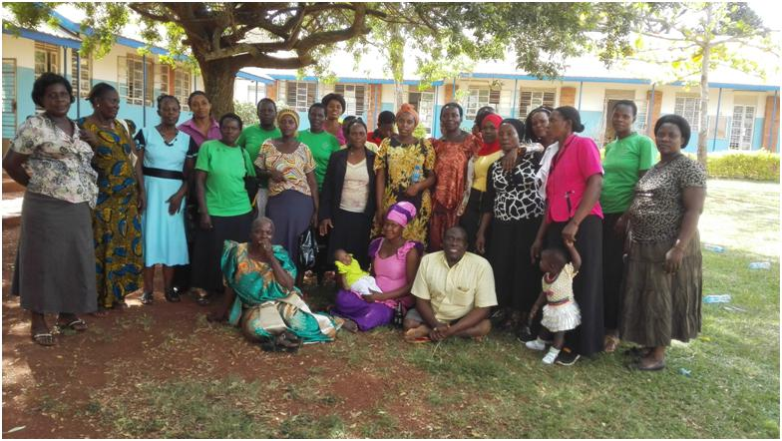

- Upcoming Activities for March 2017
  - Follow up on WiB program participants
  - Posting updates on Twitter and Facebook
  - Disbursement of WiB phase VII items scheduled for 1st to 15th March 2017
  - Ensuring compliance with Jinja Municipal Council statutory requirements.

Annex 1: Summary March 2017, Financial Requirements
Item | Cost (UGX)
APM Internet | 129,000
Office Petty Cash | 20,000
APM Lunch | 100,000
Total | 249,000

Annex II: Women in Business (WiB) Phase VII Budget
sn | Name | Item | Qty | Rate(shs) | Amount | Individual Contribution | Actual Loan Less Individual Contribution | Operation fee | Total Amount to be paidback (2 words not 1) | Repayment Plan | Pay Back (weeks)
1 | Odongo Agatha ( paper beads, jewerly & bags) | Materials (papers, vanish & cloth) | 1 | 300,000 | 300,000
 | Odongo Agatha ( paper beads, jewerly & bags) | Papers (a bundle) | 1 | 100,000 | 100,000
 | Sub total |  |  |  | 400,000 | 40,000 | 360,000 | 18,000 | 378,000 | 35,000 | 10
 |  |  |  |  |  |  |  |  | -
2 | Kagoya Lydia | Sugar | 1 | 180,000 | 180,000 |  |  |  | -
 | Kagoya Lydia | Rice | 1 | 120,000 | 120,000
 | Sub total |  |  |  | 300,000 | 30,000 | 270,000 | 13,500 | 283,500 | 25,000 | 11
 |  |  |  |  |  |  |  |  | -
3 | Bagambirebyo Lucy (Drugshop) | Stock (Medicine) | 1 | 300,000 | 300,000 |  |  |  | -
 | Sub total |  |  |  | 300,000 | 30,000 | 270,000 | 13,500 | 283,500 | 25,000 | 11
 |  |  |  |  |  |  |  |  | -
4 | Mugaru Peninah (Drug shop) | Fridge | 1 | 800,000 | 800,000 |  |  |  | -
 | Sub total |  |  |  | 800,000 | 200,000 | 600,000 | 30,000 | 630,000 | 40,000 | 15
 |  |  |  |  |  |  |  |  | -
5 | Sajjabi Hasifa (Outside catering) | Plastic chairs | 50 | 20,000 | 1,000,000 |  |  |  | -
 | Sub total |  |  |  | 1,000,000 | 100,000 | 900,000 | 45,000 | 945,000 | 50,000 | 18
 |  |  |  |  |  |  |  |  | -
6 | Sowobi Monica (Tailoring) | Clothing Materials (Rolls of uniforms) | 2 | 150,000 | 300,000 |  |  |  | -
 | Sub total |  |  |  | 300,000 | 30,000 | 270,000 | 13,500 | 283,500 | 25,000 | 11
 |  |  |  |  |  |  |  |  | -
7 | Majimbi Sarah (RainWater harvesting) | Fencing Materials | 1 | 600,000 | 600,000 |  |  |  | -
 | Sub total |  |  |  | 600,000 | 60,000 | 540,000 | 27,000 | 567,000 | 40,000 | 14
 |  |  |  |  |  |  |  |  | -
8 | Namulondo Haisfa (Nursery school) | Cement | 10 | 30,000 | 300,000 |  |  |  | -
 | Sub total |  |  |  | 300,000 | 30,000 | 270,000 | 13,500 | 283,500 | 25,000 | 11
 |  |  |  |  |  |  |  |  | -
9 | Namale Zaituni (Outside catering) | Warmer | 1 | 185,000 | 185,000 |  |  |  | -
 |  | Plates (Dozens) | 2 | 23,000 | 46,000 |  |  |  | -
 | Sub total |  |  |  | 231,000 | 23,100 | 207,900 | 10,395 | 218,295 | 25,000 | 8
 |  |  |  |  |  |  |  |  | -
10 | Kisakye Betty | Table | 1 | 60,000 | 60,000 |  |  |  | -
 |  | Seats | 12 | 20,000 | 240,000
 | Sub total |  |  |  | 300,000 | 30,000 | 270,000 | 13,500 | 283,500 | 25,000 | 11
 |  |  |  |  |  |  |  |  | -
11 | Mawubanya Evelyn (Bakery) | Sugar | 1 | 180,000 | 180,000 |  |  |  | -
 |  | Baking flour (cartons) | 2 | 60,000 | 120,000
 | Sub total |  |  |  | 300,000 | 30,000 | 270,000 | 13,500 | 283,500 | 25,000 | 11
 |  |  |  |  |  |  |  |  | -
12 | Kasambira Joy (Salon) | Salon Stock | 1 | 500,000 | 500,000 |  |  |  | -
 | Sub total |  |  |  | 500,000 | 50,000 | 450,000 | 22,500 | 472,500 | 35,000 | 13
 |  |  |  |  |  |  |  |  | -
13 | Babirye Ruth (Tailoring) | Clothing Materials | 1 | 240,000 | 240,000 |  |  |  | -
 | Sub total |  |  |  | 240,000 | 24,000 | 216,000 | 10,800 | 226,800 | 25,000 | 9
 |  |  |  |  |  |  |  |  | -
14 | Matege Rabecca (Tailoring) | Clothing materials (Rolls of Uniforms) | 1 | 500,000 | 500,000 |  |  |  | -
 | Sub total |  |  |  | 500,000 | 50,000 | 450,000 | 22,500 | 472,500 | 35,000 | 13
 |  |  |  |  |  |  |  |  | -
15 | Namwase Mary (Tailoring) | Clothing Materials (Bitenge) | 1 | 500,000 | 500,000 |  |  |  | -
 | Sub total |  |  |  | 500,000 | 50,000 | 450,000 | 22,500 | 472,500 | 35,000 | 13
 |  |  |  |  |  |  |  |  | -
16 | Namuwaya Racheal (Tailor) | Clothing Materials (Rolls of uniforms) | 1 | 300,000 | 300,000 |  |  |  | -
 | Sub total |  |  |  | 300,000 | 30,000 | 270,000 | 13,500 | 283,500 | 25,000 | 11
 |  |  |  |  |  |  |  |  | -
17 | Sempa Jennipher (makes Medicinal Juice (cumbucha)) | Materials | 1 | 500,000 | 500,000 |  |  |  | -
 | Sub total |  |  |  | 500,000 | 50,000 | 450,000 | 22,500 | 472,500 | 35,000 | 13
 | Grand total |  |  |  | 7,071,000 | 857,100 | 6,513,900 | 325,695 | 6,839,595 | 530,000

